|  |
| --- |
| **National University of Computer and Emerging Sciences** |
| In Lab Exercise 4  “Nested Queries” |
|  |
| Database Systems |
| Fall 2024 |

Department of Computer Science

FAST-NU, Lahore, Pakistan

Database:

Members:

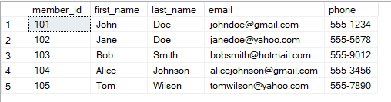

Book:

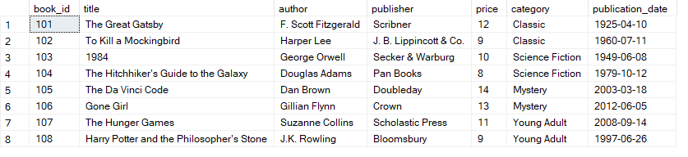

Borrow:

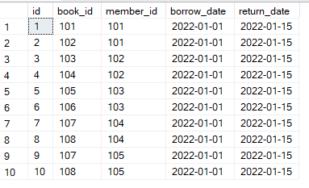

Questions:

Q1. Write a query to find the names and email addresses of all members who have borrowed at least one book.

Q2. Write a query to find the titles of all books that have been borrowed by members whose email address contains the word "gmail".

Q3. Find the titles of books that have been borrowed by members who have borrowed books in the category "Classic".

Q4. Write a query to find the titles of all books that have been borrowed more than once.

Q5. Write a query to find the names and phone numbers of all members who have borrowed books with a price greater than $10.

Q6. Write a query to find the number of books borrowed by each member.

Q7. Write a query to find the titles of all books that have been borrowed by members whose last name starts with "D".

Q8. Write a query to find the names of all members who have borrowed books published before 1990.

Q9. Write a query to find the titles of all books that have been borrowed by members whose first name starts with "J" and last name ends with "n".

Q10. Write a query to find the names of all members who have borrowed the same book more than once.

Q11. Retrieve the first name and last name of the members who have not borrowed any books.

Q12. Retrieve the title and author of the books that have been borrowed by members.

Q13. Retrieve the title of the books that have been borrowed by members whose last name is "Doe".

Q14. Find the members who have borrowed at least one book, but not returned any books yet.